Use Cases  
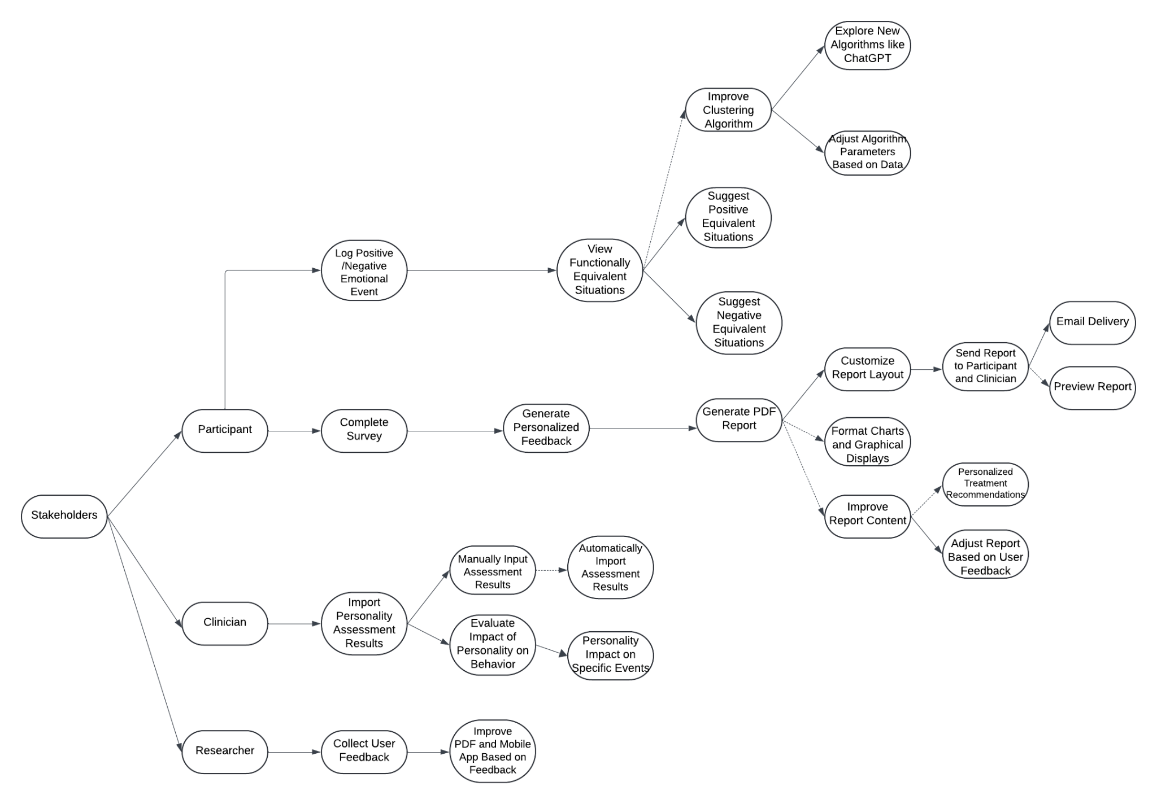

**Generate and Send Personalized PDF Report**

| Pre-condition | Participants completed a Qualtrics web survey. |
| --- | --- |
| Post-condition | A PDF report was generated and emailed to participants and clinicians. |
| Basic Path | 1. The system detects that the participant has completed all Qualtrics survey questions.  2. The system automatically generates a personalized PDF report that summarizes the participant's personality assessment results and recommended treatment strategies.  3. The PDF report is sent to the participant and clinician via the system's preconfigured email service. |
| Alternative Path | -In step 2, if an error occurs when generating the PDF, the system will retry the generation. If multiple failures occur, the system will generate an error message and remind the administrator to generate the report manually.  -In step 3, if the email fails to be sent, the system will log the error and continue to try to send in the background queue until it succeeds. |
| Related Requirements | -PDF generation and automation  -Qualtrics integration with Python scripts  -Email sending and notification system |

**Log Emotional Event**

| Pre-condition | The user has logged into the mobile self-monitoring app. |
| --- | --- |
| Post-condition | The sentiment event is successfully recorded and saved to the database along with a timestamp. |
| Basic Path | 1. The user opens the mobile self-monitoring app.  2. The user selects the "Record Emotional Event" button.  3. The app prompts the user to enter the event type (positive or negative), emotional feelings, related behaviors, and thoughts.  4. After the user enters and submits, the system stores the emotional event on the local device or in a cloud database. |
| Alternative Path | -In step 4, users can choose to skip certain fields (such as thoughts or behaviors) and only record emotional feelings.  -If the device is offline, the system will automatically sync the data after the network connection is restored. |
| Related Requirements | -Event logging and local storage  -Database synchronization and backup |

**View Functionally Equivalent Situations**

| Pre-condition | The user has recorded an emotional event. |
| --- | --- |
| Post-condition | Suggestions of functionally equivalent scenarios based on the clustering algorithm are displayed to the user. |
| Basic Path | 1.The user clicks on the option to view functionally equivalent situations.  2.The system analyzes the emotional events recorded by the user based on a clustering algorithm and recommends situations similar to the previous ones.  3.The system displays the suggested "functionally equivalent situations", including possible coping behaviors, related thoughts and strategies. |
| Alternative Path | -If there is not enough data to generate contextual suggestions, the system will prompt the user to record more emotional events to get more precise suggestions.  -The user can choose to manually adjust or filter contextual suggestions to suit their personal needs. |
| Related Requirements | -Clustering algorithm and data analysis  -Situational suggestion generation and display |

**Optimize PDF Report Content**

| Pre-condition | The system has generated a personalized PDF report. |
| --- | --- |
| Post-condition | The system has generated a personalized PDF report.  The charts, explanations, and treatment recommendations in the PDF report have been optimized for easy understanding. |
| Basic Path | 1. The system generates a preliminary PDF report, including the participant's personality assessment results and basic chart presentation.  2. The system adjusts the chart format, color, layout, etc. in the report based on user feedback or specified optimization rules.  3. The system adds explanatory text to the report to help users understand the assessment results and provide personalized treatment recommendations for specific personality components.  4. The system generates and stores the final PDF report. |
| Alternative Path | -In step 2, users or clinicians can manually modify certain report contents (such as chart style or explanation content).  -In step 3, the system automatically generates personalized treatment intervention recommendations based on different evaluation results. |
| Related Requirements | -Report content optimization  -User experience data collection and feedback |

**Import Qualtrics Assessment Results**

| Pre-condition | Participants completed a Qualtrics survey. |
| --- | --- |
| Post-condition | The personality assessment results have been successfully imported into the mobile phone self-monitoring application. |
| Basic Path | 1. The clinician logs into the mobile app and opens the participant's profile.  2. The clinician manually enters or imports the Qualtrics assessment results.  3. The system automatically associates the assessment results with the participant's daily mood record and prompts the impact in future events. |
| Alternative Path | -In step 2, clinicians can choose to manually enter the assessment results instead of automatically importing them.  -If the assessment results are incorrect, the system will prompt and allow the doctor to re-enter or correct the data. |
| Related Requirements | -Manual input and automated import of assessment data  -Association of assessment results with sentiment records |

**Collect User Experience Data**

| Pre-condition | The user has interacted with the system (completed a survey or used a self-monitoring app). |
| --- | --- |
| Post-condition | User experience data has been saved successfully. |
| Basic Path | 1. The system prompts users to fill out the user experience feedback questionnaire regularly or in specific situations (such as after the user completes a certain function).  2. Users provide feedback through the Qualtrics platform or the feedback form in the application, including the degree of understanding of the PDF report, the experience of using the mobile application, etc.  3. The system collects all feedback data and stores it in the cloud database for subsequent analysis and research. |
| Alternative Path | -Users can choose to skip the feedback survey, but the system will prompt them next time.  -If the user's feedback contains specific issues (such as the report is incomprehensible), the system will generate further improvement suggestions. |
| Related Requirements | Collection and storage of user experience data  Relationship between user feedback and system optimization |

**Non-Functional Requirements**

**System Performance**

The system should be able to scale as the number of users grows, especially when a large number of clinical graduate students or psychological clinics use the system at the same time. The system should remain stable during peak usage and ensure a smooth user experience.

After a participant completes a Qualtrics survey, the PDF report with personalized assessment feedback should take no longer than 5 seconds to generate, and the email delivery delay should be no longer than 10 seconds.

**Data Storage and Management**

All emotional events, evaluation data, and user feedback should be accurately stored in a MongoDB database, and the integrity of the data should be ensured. The database should support automatic backup and recovery mechanisms to ensure that no data is lost in the event of a system failure.

**Security**

The system should have role-based permission management capabilities to ensure that only authorized users (such as clinicians and researchers) can access specific assessment results and user emotional events.

**System Availability**

If the system fails, it should have automatic recovery and error handling mechanisms to ensure that the user experience is not affected. For example, when PDF generation fails, the system should automatically retry or send a notification to the administrator.

**User Experience**

The application should have an intuitive user interface so that users can start using the system without having to read a lot of documentation. The emotional event recording and feedback functions in the mobile self-monitoring application should be simple and easy to understand, and participants can complete them quickly.

**Maintainability**

The system should be designed with an extensible and maintainable architecture to support the addition or modification of future functions. The development team should be able to quickly locate and fix potential problems in the system and update it without affecting users.